Long Short-Term Memory (LSTM) Networks
Table of Contents
1. Introduction to LSTM 1
2. Issues with Recurrent Neural Networks (RNNs) 1
Short-term Memory Problem 1
Vanishing and Exploding Gradient Problems 2
Difficulty in Learning Long-term Dependencies 2
3. LSTM Networks: Overcoming RNN Limitations 2
4. LSTM Architecture 2
5. LSTM Structure: The Three Gates 2
Forget Gate 2
Input Gate 2
Output Gate 2
6. LSTM Cell State and Updating Mechanism 3
Candidate State Computation 3
Memory Update 3
7. Summary and Key Takeaways 3
8. Annex 4
Common Activation Functions and Their Formulas 4
key formulas used in LSTM networks: 4
Forget Gate 4
Input Gate 4
Candidate Cell State 5
Cell State Update 5
Output Gate 5
Hidden State Update 5
Example: Calculating Weight and Bias Matrices in LSTMs 5
Numerical Example 6
Jupyter Notebook Demo 7

1. Introduction to LSTM
LSTM (Long Short-Term Memory) networks are a special kind of recurrent neural network (RNN) capable of learning long-term dependencies. They were introduced to overcome the limitations of standard RNNs, such as short-term memory and vanishing gradient problems. LSTMs are widely used in tasks like speech recognition, time-series prediction, and natural language processing.

2. Issues with Recurrent Neural Networks (RNNs)

Short-term Memory Problem
Traditional RNNs struggle to remember information from distant time steps. They primarily rely on short-term memory, making them ineffective for tasks requiring long-term dependencies.

Vanishing and Exploding Gradient Problems
During backpropagation, gradients can become excessively small (vanishing gradient) or excessively large (exploding gradient), leading to slow learning or instability.

Difficulty in Learning Long-term Dependencies
Standard RNNs find it hard to retain useful information across long sequences, impacting performance in tasks that require context retention over time.

3. LSTM Networks: Overcoming RNN Limitations
LSTMs address the issues of standard RNNs by introducing memory cells and gate mechanisms. Instead of relying solely on short-term memory, LSTMs maintain a more stable long-term memory, improving performance in sequential data tasks. Unlike RNN cells, LSTM cells selectively decide what to store, discard, and output, making them more efficient.

4. LSTM Architecture
LSTMs consist of three key components:
- Memory cell (C_t): Stores long-term information.
- Gates (Forget, Input, Output): Regulate information flow.
- Hidden state (h_t): Used for predictions and next time-step computations.
The memory cell and gates work together to update and manage information efficiently.

5. LSTM Structure: The Three Gates

Forget Gate
- Determines which information from the previous cell state should be discarded.
- Uses the sigmoid function (σ) to generate values between 0 and 1.
- Formula:

Input Gate
- Decides which new information should be added to memory.
- Uses a combination of the sigmoid (σ) and tanh functions.
- Formula:

Output Gate
- Controls what part of the memory should be output at the current time step.
- Uses the sigmoid function to determine which information to pass forward.
- Formula:

6. LSTM Cell State and Updating Mechanism

Candidate State Computation
- The candidate memory state is computed using the tanh function.
- Formula:

Memory Update
- The cell state is updated based on the forget and input gate values.
- Formula:
- The tanh activation function ensures values remain between -1 and +1, stabilizing learning.

7. Summary and Key Takeaways
- RNNs suffer from short-term memory and vanishing gradients.
- LSTMs introduce memory cells and gates to store long-term dependencies.
- Forget, Input, and Output gates control the information flow in LSTMs.
- The memory cell maintains important information, making LSTMs effective for sequence-based tasks.
- LSTMs are widely used in NLP, speech processing, and time-series forecasting.

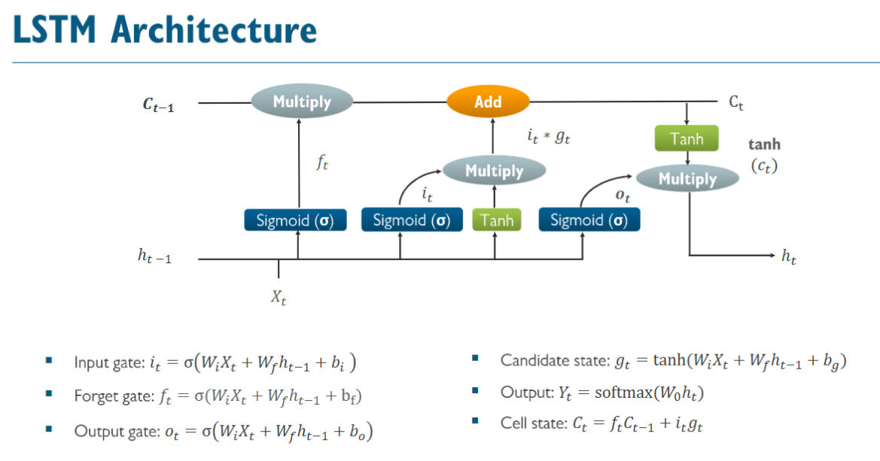

8. Annex

Common Activation Functions and Their Formulas
Here are the formulas for commonly used activation functions in neural networks:
- Sigmoid Function
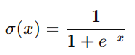
​Output range: (0,1)
  - Used in LSTMs for gates.
- Tanh (Hyperbolic Tangent) Function
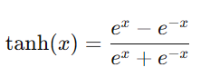
​Output range: (−1,1)
  - Used in LSTMs for candidate cell state.
- ReLU (Rectified Linear Unit)
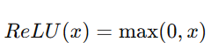
  - Output range: (0,∞)
  - Used in deep networks to prevent vanishing gradients.
- Softmax Function (for multi-class classification)
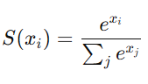
​​
  - Converts logits into probability distributions.

key formulas used in LSTM networks:

Forget Gate
Determines which information from the previous cell state should be discarded.

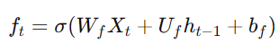
Input Gate
Decides which new information should be added to memory.

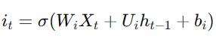
Candidate Cell State

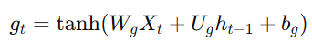
Cell State Update
The cell state is updated based on the forget and input gate values.

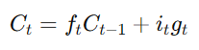
Output Gate
Controls what part of the memory should be output at the current time step.

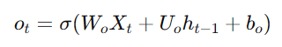
Hidden State Update
The hidden state is computed using the updated cell state and the output gate.
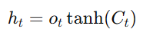
These formulas define how LSTM networks manage long-term dependencies effectively.

Example: Calculating Weight and Bias Matrices in LSTMs
Let's assume we have an LSTM cell with:
- Input size = 3 (features in input Xt​)
- Hidden size = 2 (number of LSTM units)
The weight matrices are:
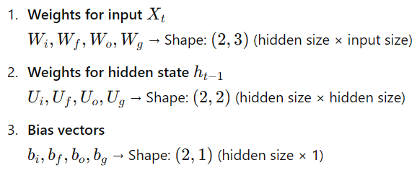

Numerical Example
Let's consider a simple input:
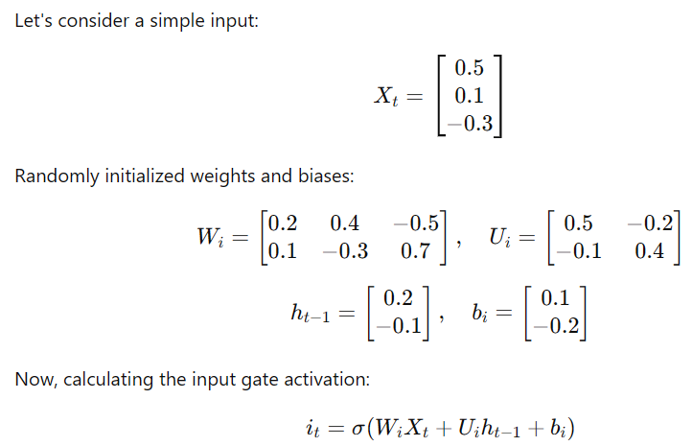

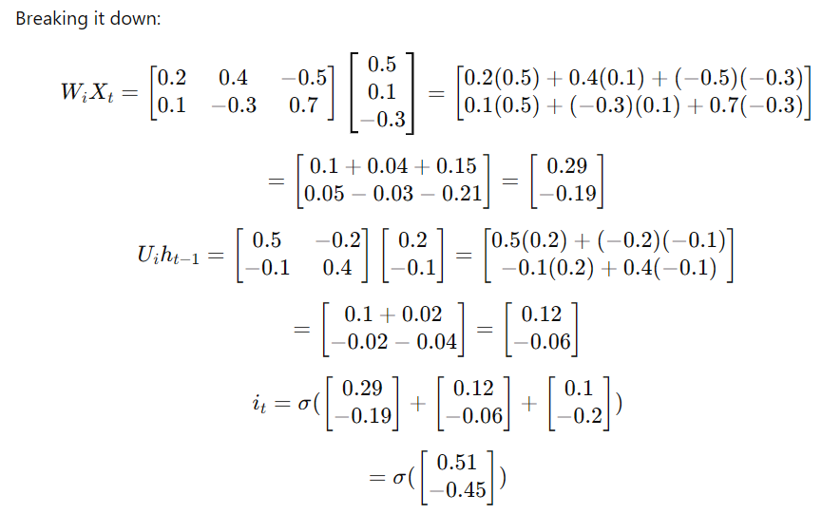

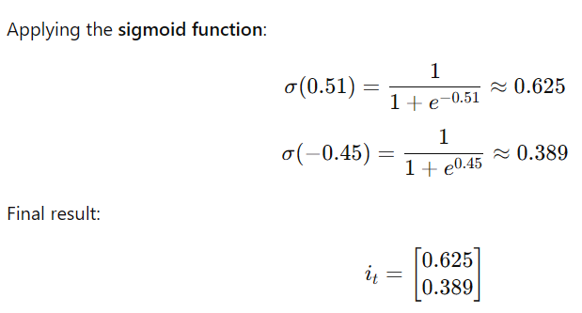

Jupyter Notebook Demo
I'll now generate a Jupyter Notebook that contains:
- Implementation of LSTM step-by-step.
- Calculation of weight and bias transformations.
- Visualization of activation functions.

import numpy as np
import matplotlib.pyplot as plt
def sigmoid(x):
return 1 / (1 + np.exp(-x))
def tanh(x):
return np.tanh(x)
# Sample input vector X_t (3 features)
X_t = np.array([[0.5], [0.1], [-0.3]])
# Sample hidden state from previous timestep h_{t-1} (2 units)
h_t_1 = np.array([[0.2], [-0.1]])
# Random weight matrices for input and hidden layers
W_i = np.array([[0.2, 0.4, -0.5], [0.1, -0.3, 0.7]])
U_i = np.array([[0.5, -0.2], [-0.1, 0.4]])
b_i = np.array([[0.1], [-0.2]])
# Compute input gate activation
z_i = np.dot(W_i, X_t) + np.dot(U_i, h_t_1) + b_i
i_t = sigmoid(z_i)
print("Input Gate Activation:")
print(i_t)
# Generate plots for activation functions
x_vals = np.linspace(-5, 5, 100)
plt.figure(figsize=(12, 5))
plt.subplot(1, 2, 1)
plt.plot(x_vals, sigmoid(x_vals))
plt.title("Sigmoid Function")
plt.grid()
plt.subplot(1, 2, 2)
plt.plot(x_vals, tanh(x_vals))
plt.title("Tanh Function")
plt.grid()
plt.show()

